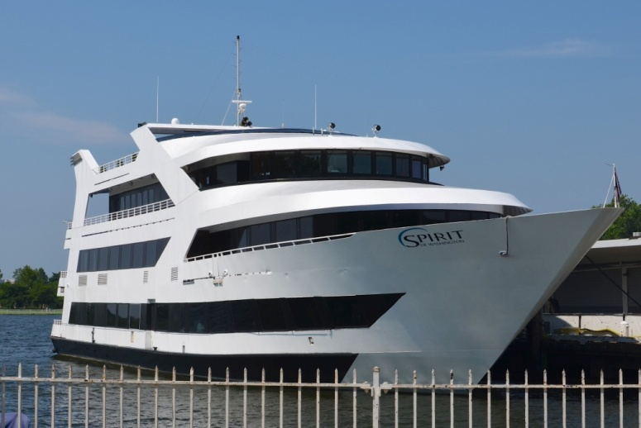
SHEPHERD PARK AARP CHAPTER 2667
Spirit of Washington Cruise

Date: Wednesday, June 21, 2017
Price: $67.00 per person
Time: 12 noon – 2:00 pm
(Boarding 11:15 am)

NOTE: FREE parking at the Safeway (1100 4th St SW, Washington, DC 20024)
with FREE Shuttle service from Safeway parking lot to Spirit Cruise lines. The shuttle bus comes every 5 to 10minutes right at the entrance (4th Street) to Safeway. Arrive at Safeway no later than 10:45 am.

PAYMENT INSTALLMENTS:
First payment due March 22nd $30.00 Second payment due April 19th $37.00
NO REFUND * EXCEPT IN EMERGENCY

Name______________________________________ Guest_______________________

Telephone____________________________ Total $______________________

Checks payable to: Shepherd Park AARP Chapter 2667
Mail to: Andrew Mickens, Jr. 7428 8th Street, NW Washington DC 20012

For further information contact:
Andrew Mickens, Jr. 202-726-0140
Donna Graham 301-585-4759
Barbara Schools 202-722-1225

